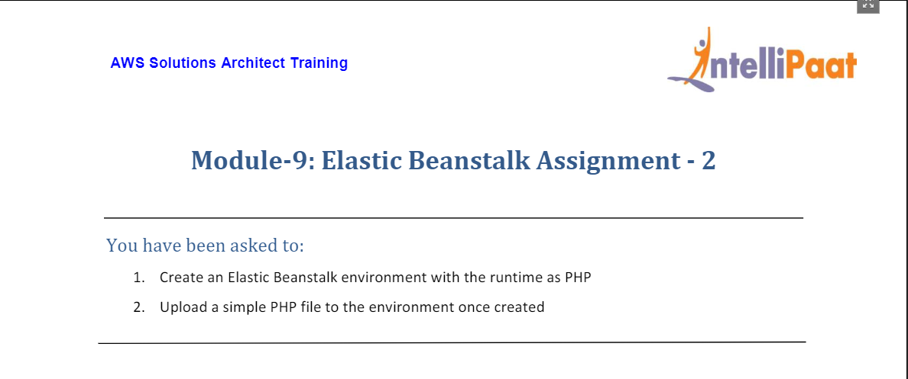

1. For this assignment, we head to Elastic Beanstalk service through AWS Management Console

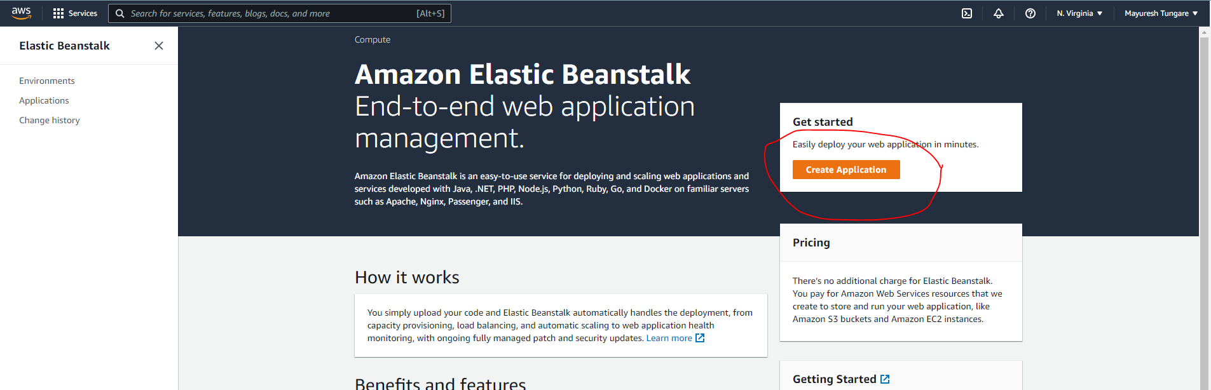

1. Fill out the details as shown below to start creating the Elastic Beanstalk application:

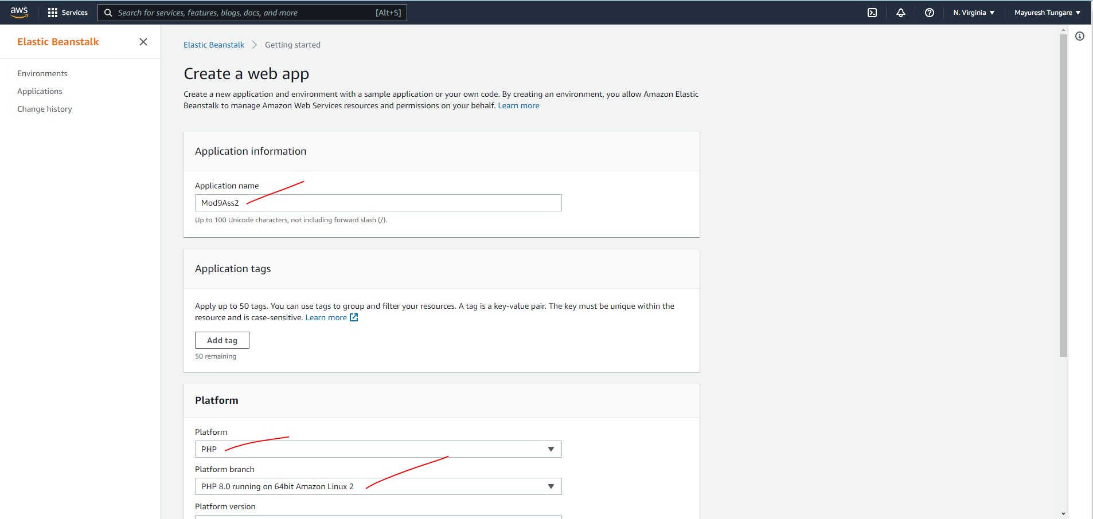

1. Once all details are entered, you can click on Create application as shown below:

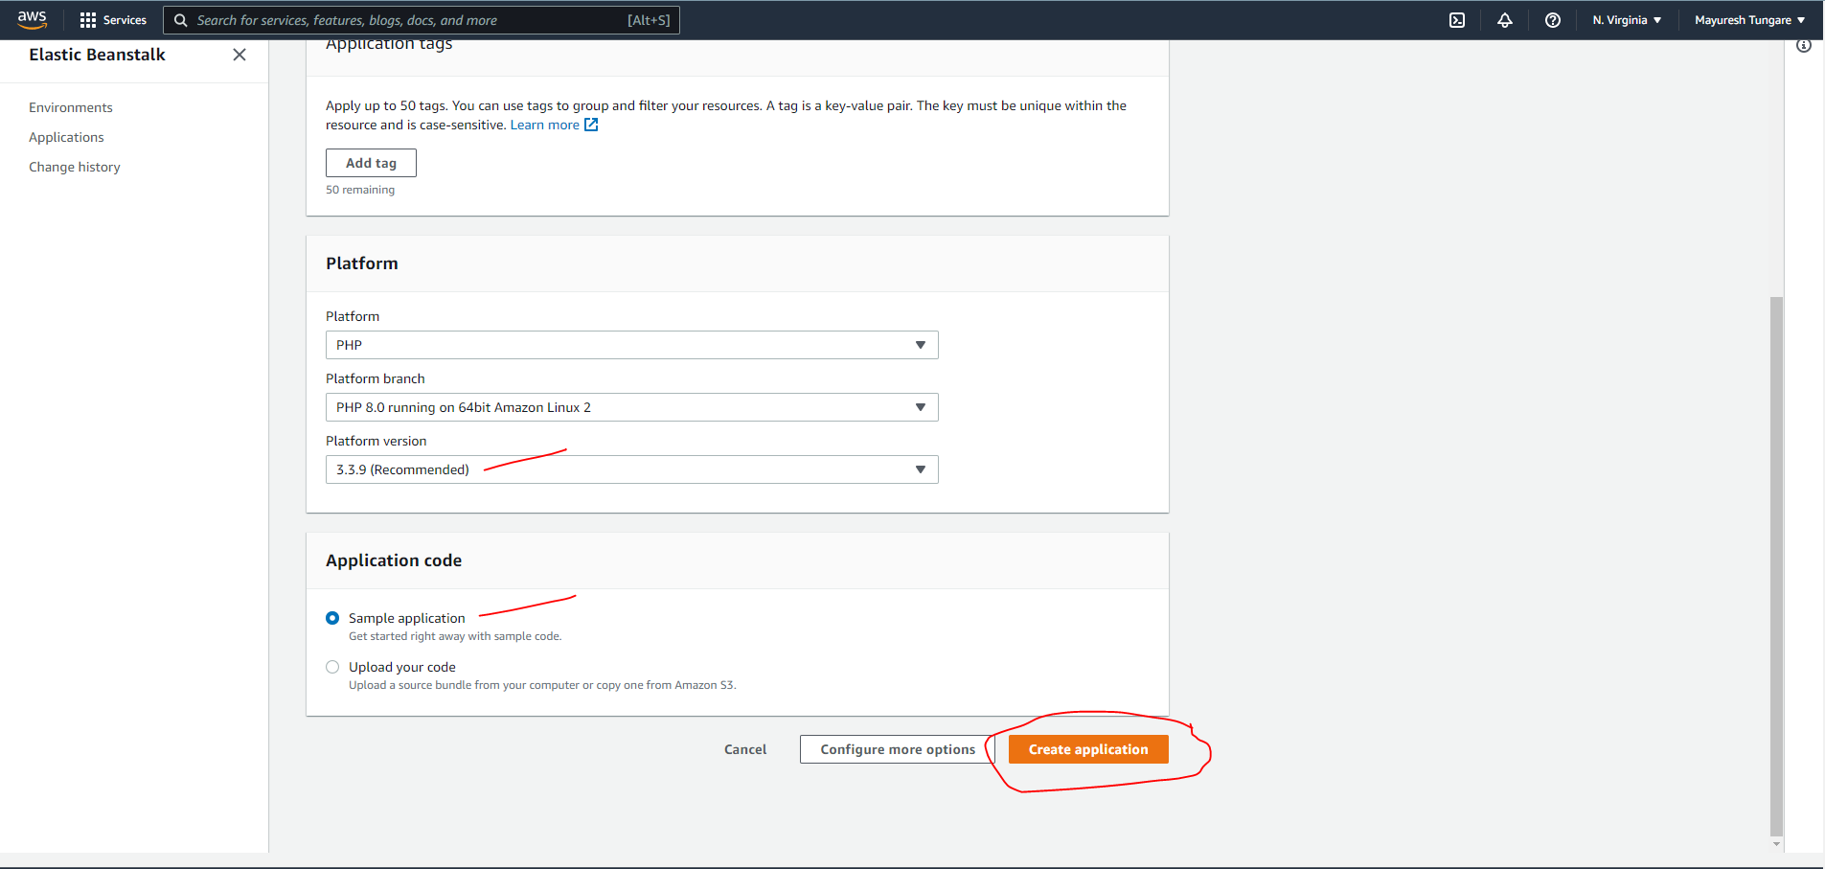

1. As you will observe, it will start creating the environment for the application:

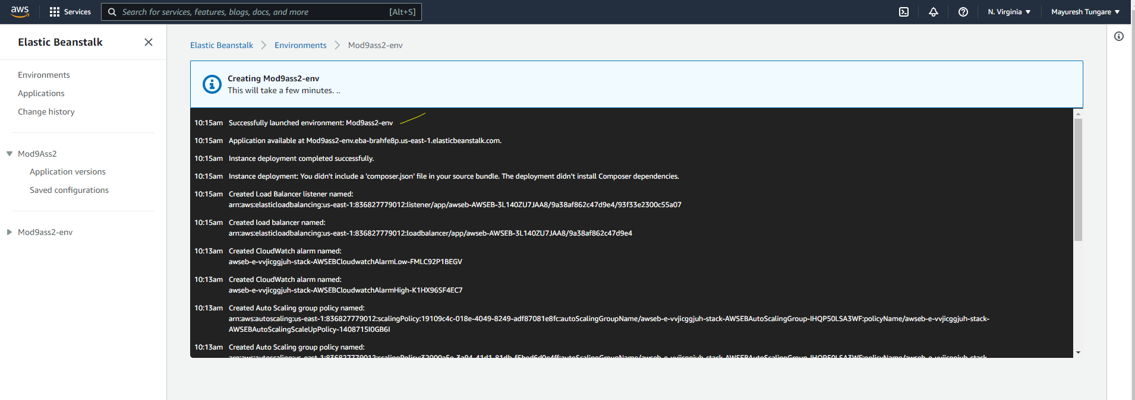

1. The final confirmation will be seen as below:

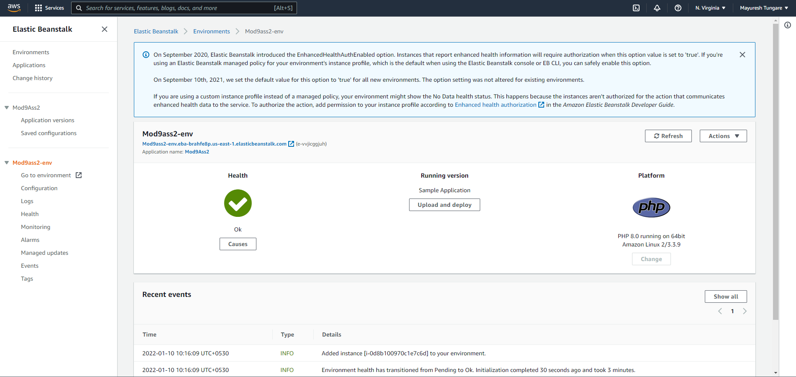

1. Now, we move to next part of the assignment, for which we create a simple php file as shown below:

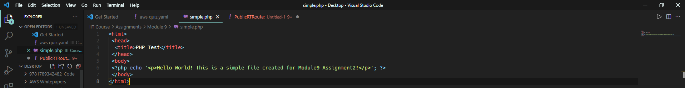

1. To upload file, we click on ‘upload and deploy’ option as below:

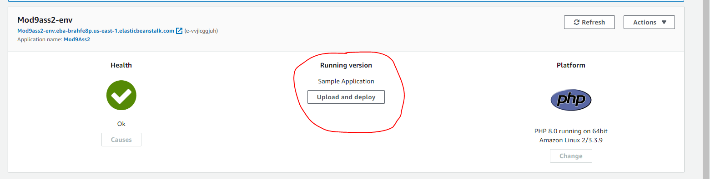

When we check the URL, we see the application launched successfully:

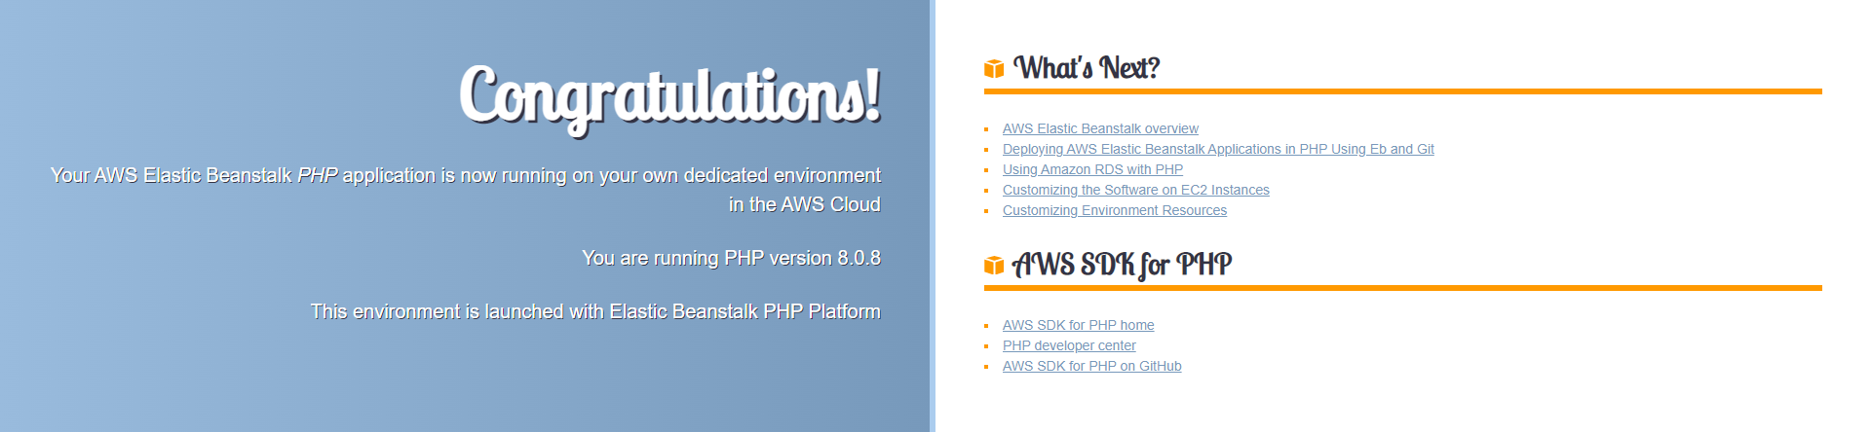

We also observe that Elastic Beanstalk has also create an instance on its own

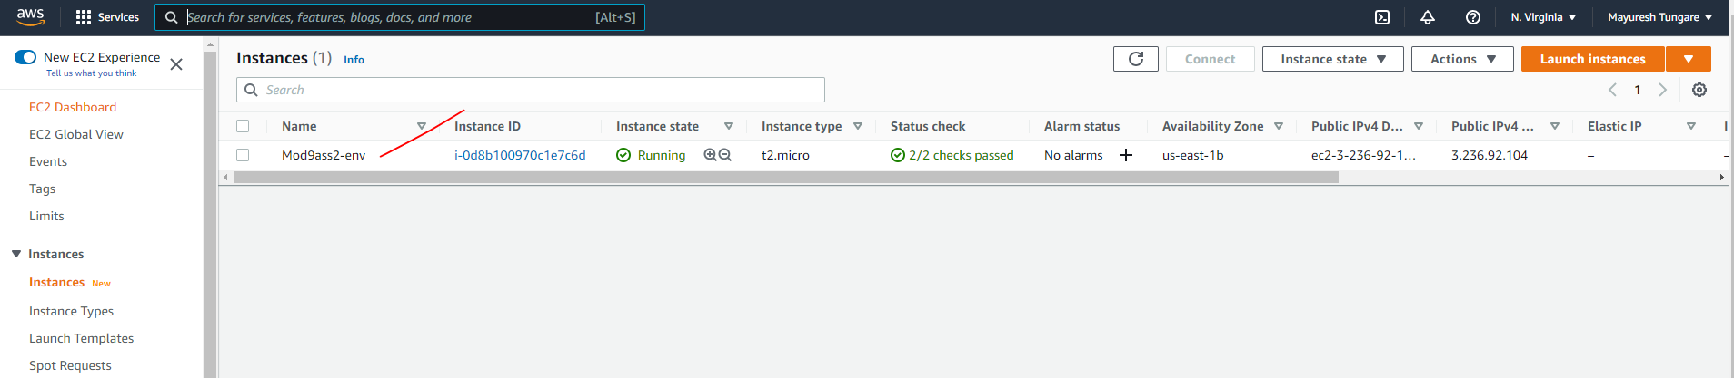

1. On the next screen, upload the file, enter required details and click on deploy as shown below:

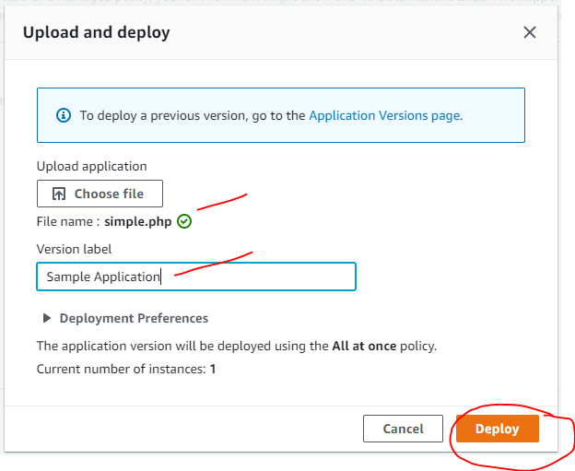

1. Thus, this assignment is now complete.